# AcqManager

# Stimulation and Responses (Paradigms, Task and Presentation)

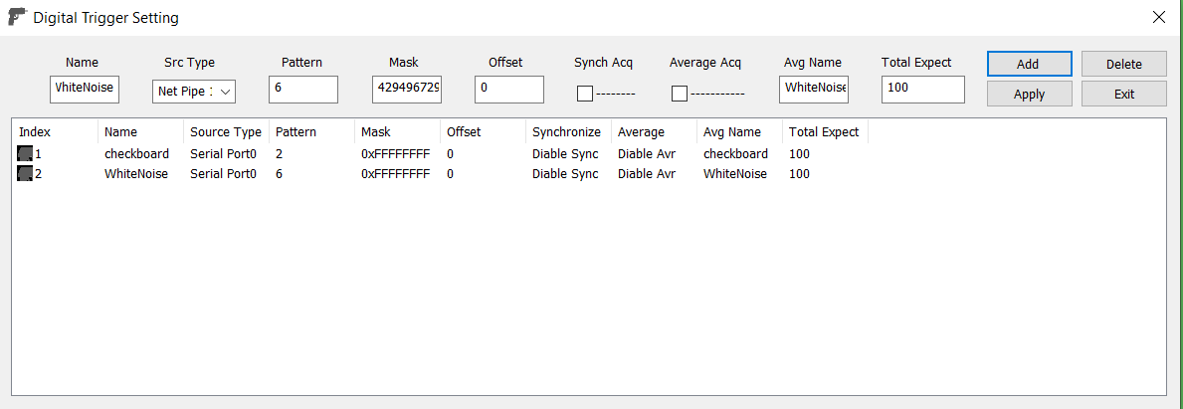

# DISCLAIMER

Software develops quickly to take the advantages of hardware and new algorithms. We have used reasonable effort to include accurate and up-to-date information in this manual; it does not, however, make any warranties, conditions or representations as to its accuracy or completeness. We assume no liability or responsibility for any errors or omissions in the content of this manual. Your use of this manual is at your own risk. Under no circumstances and under no legal theory shall the authors be liable for any indirect, direct, special, incidental, punitive, exemplary, aggravated or consequential damages arising from your use of this manual.

Features and specifications of this software program are subject to change without notice. This manual contains information and images about AcqManager, its user interface, GUI and its other signal processing algorithms, publications that are protected by copyright.

All rights reserved. This publication may be reproduced, stored in a retrieval system, or transmitted, in any form or by any means, electronic, mechanical, photocopying, recording, or otherwise, with prior permission by the authors.

*Sending Your Comments and Critiques:* We’d like to hear from you. Your comments and suggestions for improving this document are welcome and appreciated. Please e-mail your feedback to support@mecurer.com

Thank you.

Contents

AcqManager 1

Stimulation and Responses (Paradigms, Task and Presentation) 1

DISCLAIMER 2

Contents 3

*Warnings and Cautions* 4

Preface 5

Setup Paradigm Trigger 6

Setup WiFi Pipe for Acq to Connect to Stimulation (BrainX) 8

Link order 8

Setup Parallel Port connection 9

Setup Serial Port connection 10

# *Warnings and Cautions*

This software supports data acquisition for magnetoencephalography (MEG), electroencephalography (EEG) and other bioelectromagnetic signals. Though MEG and EEG waveforms appear similar, they have different unit in amplitude. If the MEG and EEG data recorded simultaneously, their time unit or temporal resolution is typically the same.

Modern MEG/EEG systems typically have MEG/EEG sensor/electrode channels as well as other channels. For example, trigger channel, head-localization channels and additional ADC (analog-to-digital) channels. To avoid problems, please pay attention to the channel names and the amplitude value/unit. Their values may be of different orders of magnitude. Unexpected results may occur if their values are mixed in measurements.

When performing waveform analysis, regardless of whether MEG or EEG or both are displayed, ensure that the data are appropriately filtered with DC-offset/linear-trend removal. If the waveforms had very large amplitude (e.g. > 3 pt), it is recommended that you identify possible noise.

There are a set of source localization algorithms in the program. Each source localization algorithm has been designed and tested for specific reasons. To ensure the quality and visibility, all source localization algorithms will generate a volumetric source image, which can be considered as an image with millions of “dipoles” or multi-value-voxel, which is significantly different from the conventional magnetic source imaging (MSI) or equivalent current dipoles.

Head movement during MEG recordings may affect the accuracy of source imaging. If subjects move too much during MEG recordings, the MEG results are more than likely poor.

The accuracy of the structural images (MRI/CT) may also affect the MEG results if the conventional magnetic source imaging (MSI) is used. If MRI/CT is distorted, the combination of MEG/MRI/CT will be low-quality. In addition, multiple local sphere, head model or other structural constrained source localization my internally use the MRI/CT images. Any analysis based on those distorted images may yield unexpected or poor results.

The following warnings and cautions appear in this guide. Please ensure you are aware of all the operations and interpretations.

# Preface

The Main Frame is one of the core windows of AcqManager software. It is used as the primary tool to view MEG, EEG, MCG, ECG, triggers and other data, mark and classify the data, and identify results of interest for academic or clinical purposes. Importantly, the Main Frame provides graphic user interface (GUI) for access other function. In other words, it is also often used to launch other windows such as source localization.

This guide describes the operation of the AcqManager application for MEG/EEG/MCG/ECG. Though there are many functions related to MRI/CT, analyses of MRI/CT are not the focuses of this guide.

*Determining the Software Version*

In the Main Frame: select Help -> About.

The About Dialog will show the version of the software.

*Intended Audience*

This guide is intended for anyone needing to record and view (online) data with an appropriate hardware system. It assumes the technologist/operator is familiar with standard MEG/EEG/MCG/ECG procedures and with the Windows operating systems.

*Document Structure*

Documents are generally provided in both Microsoft Word® format and Adobe® Acrobat® PDF (Portable Document Format). All editions are distributed on Flash Driver, CD or websites with the related software, and include bookmarks and hyperlinks to assist navigating the document. Please feel free to send your critiques, corrections, suggestions and comments to support@mecurer.com.

*Conventions*

Numeric: Numeric values are generally presented in decimal but in special circumstances may also be expressed in hexadecimal or binary. Hexadecimal values are shown with a prefix of 0x, in the form 0x3D. Binary values are shown with a prefix of 0b, in the form 0b00111101. Otherwise, values are presumed decimal.

Units: Units of measure are given in metric. Where measure is provided in imperial units, they are typically shown in parenthesis after the metric units. Biomagnetic signal strength is given in Teslas (T), the SI unit of flux density (or field intensity) for magnetic fields, also known as the magnetic induction. Typical signal strengths in biomagnetic measurements are in the order of pT (picoteslas = 10-12) or fT (femtoteslas = 10-15). Electrical signal strength is given in volts (V). Bioelectrical activity is typically quite small, measured in microvolts (mV).

# Setup Paradigm Trigger

One task is typically necessary for functional brain research is to design a paradigm or task. The paradigm (task) typically includes visual, auditory, somatosensory, motor and other stimulation. AcqManager supports a variety type of Stimulus Presentation. For brain research, there are different ways of presenting the stimuli to your subjects; we will elaborate the systems we have at the facility here.

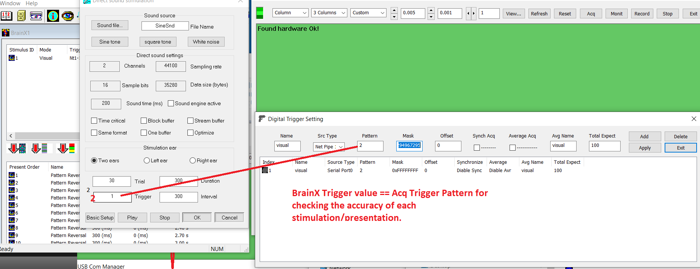

Figure 1. Digital Trigger Setting



Figure 1. Digital Trigger Setting

It is important to note that, the value of the pattern in the AcqManager should match with the trigger value in BrainX. Otherwise, the data acquisition software will treat the trigger as junk-trigger.

Visual stimulation

Visual stimuli are projected on to the screen in front of subject. The signal is projecting though a periscope into the shielded areas onto a back-projection screen that is placed in front of the chair. The optimal positions for the screen are marked by tape on the floor for correct focus. Please make sure to place the screen at these locations before your experiment and be sure to move it towards the wall after your finish. There is a small note on the screen showing which side should face the subject. It is important to point it out that delays of visual stimulation is typically noted. To determine the delay, photodiode test can be done. Using a light diode, it has been shown a jitter of about 35 ms between the trigger codes sent from the stimulus PC to the MEG acquisition computer and the visual output in the projector screen inside the recording room that the subject sees. These results were acquired for a specific setting and therefore the researchers are encouraged to conduct their own personalized tests. They are advised to simulate the same settings as their experiment and collect the data. The photodiode and related equipment to conduct the test will be provided.

Auditory Stimulation

For delivering auditory input to the subjects, a pair of MEG compatible Tubal Insert head Phones (e.g., TIP 300 - Nicolet) can be used. The use of Nicolet TlPs maximizes interaural stimulus isolation, prevents ear canal collapse, and reduces stimulus artifact. TlPs are easy-to-use, lightweight, durable and comfortable for the patient. Use a new set of foam ear-tips for every subject. Attach the yellow foam tip to the tubes and hand it over to the subject. After use, throw away the yellow foam ear-tips, but make sure you do not dispose off the white plastic piece attached to the end of the tubes.

Triggers

During an MEG scan, stimuli from the presentation computer are presented to the subject seated) and the MEG/EEG signal is recorded on the acquisition computer simultaneously. As the stimuli are presented to the subject, a trigger pulse (digital pulse) is recorded along with the MEG signal in a separate channel and serves as a temporal marker. This is the STIM channel that contains information about the events/triggers such as start of the event, duration of the event and the event ID. These triggers are useful for time locking analysis of your MEG data such as evoked analysis etc.,

Stimulus Trigger Interface

The digital triggers are sent from the stimulus computer through the parallel port to the that is placed on the Stimulus presentation table. Any stimulus input from the Presentation computer is directly sent to subjects. The triggers sent by the computer are sent to several ways (WiFi network, serial port and parallel ports) that are directly fed to the Acquisition computer to be recorded along with the MEG signal collected from the subject

Response Triggers

The responses collected from the subject typically use an optical response pads. These responses are encoded in the trigger box (STI101) via BNC cables, that is housed inside the Trigger Cabinet shown above and are recorded in the ST101 channel along with the stim triggers (STI102) and MEG signal data. The responses signal can also be sent to the stimulation computer which integrates into paradigms and forward to the data acquisition computer.

# Setup WiFi Pipe for Acq to Connect to Stimulation (BrainX)

The software supports several connections between data acquisition computer and stimulation computer. One easy way to setup the connection is to setup a WiFi pipe to connect the stimulation computer and the data acquisition computer.

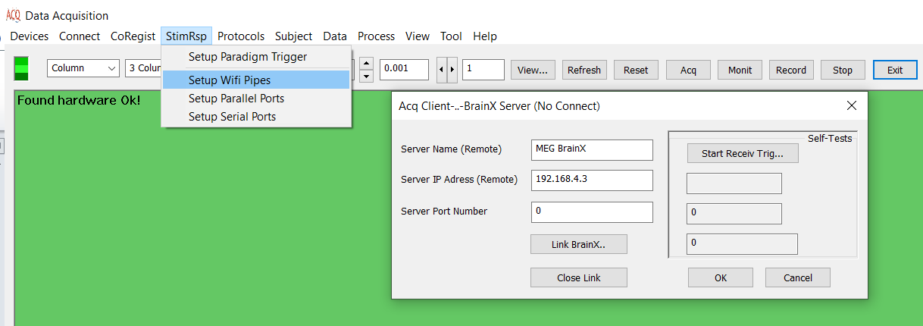

# Link order

To connect the two computer, first start the BrainX computer to listen to the Acq requests, and then click the Link BrainX. Once the two computer linked, a connection message will be displayed.

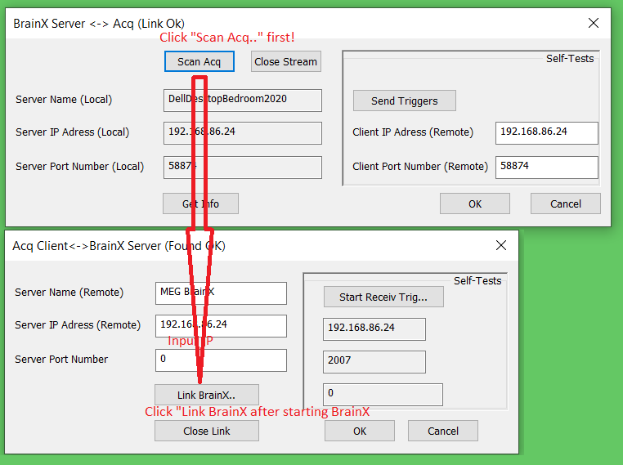

Figure 2. Link the AcqManager to the BrainX by clicking the “Scan Acqp” first, and then click the “Link BrainX”.

# Setup Parallel Port connection

If there is a parallel port cable connecting the stimulation computer and the data acquisition computer, AcqManager can setup the connection. In computing, a parallel port is a type of interface found on early computers (personal and otherwise) for connecting peripherals. The name refers to the way the data is sent; parallel ports send multiple bits of data at once (parallel communication), as opposed to serial communication, in which bits are sent one at a time. To do this, parallel ports require multiple data lines in their cables and port connectors and tend to be larger than contemporary serial ports, which only require one data line. The parallel port interface was originally known as the Parallel Printer Adapter on IBM PC-compatible computers. It was primarily designed to operate printers that used IBM's eight-bit extended ASCII character set to print text, but could also be used to adapt other peripherals. Graphical printers, along with a host of other devices, have been designed to communicate with the system.There are many types of parallel ports, but the term has become most closely associated with the printer port or Centronics port found on most personal computers from the 1970s through the 2000s. It was an industry de facto standard for many years, and was finally standardized as IEEE 1284 in the late 1990s, which defined the Enhanced Parallel Port (EPP) and Extended Capability Port (ECP) bi-directional versions. Today, the parallel port interface is virtually non-existent in new computers because of the rise of Universal Serial Bus (USB) devices, along with network printing using Ethernet and Wi-Fi connected printers.

# Setup Serial Port connection

If there is a serial cable connected the data acquisition computer and the stimulation computer, AcqManager can setup the connection. In computing, a serial port is a serial communication interface through which information transfers in or out sequentially one bit at a time.[1] This is in contrast to a parallel port, which communicates multiple bits simultaneously in parallel. Throughout most of the history of personal computers, data has been transferred through serial ports to devices such as modems, terminals, various peripherals, and directly between computers. While interfaces such as Ethernet, FireWire, and USB also send data as a serial stream, the term serial port usually denotes hardware compliant with RS-232 or a related standard, such as RS-485 or RS-422. Modern consumer personal computers (PCs) have largely replaced serial ports with higher-speed standards, primarily USB. However, serial ports are still frequently used in applications demanding simple, low-speed interfaces, such as industrial automation systems, scientific instruments, point of sale systems and some industrial and consumer products. Server computers may use a serial port as a control console for diagnostics, while networking hardware (such as routers and switches) commonly use serial console ports for configuration, diagnostics, and emergency maintenance access. To interface with these and other devices, USB-to-serial converters can quickly and easily add a serial port to a modern PC.

**Index**

E

Electroencephalography (EEG), **5**

F

femtoteslas, 6

M

Magnetic source imaging (MSI), 5

Magnetoencephalography (MEG), 5

Main Frame, 6

P

picoteslas, 6

T

Teslas (T),, 6